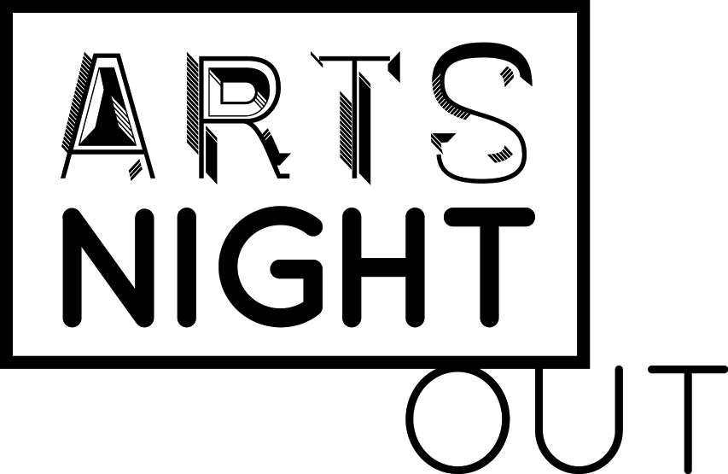

Arts Council of Greater Lansing
Venue & Artist(s) Checklist
Optional

In order to ensure that Arts Night Out venues and artist(s) establish a positive working relationship and are in agreement of how Arts Night Out event logistics will run, the Arts Council of Greater Lansing has developed a few optional resources. The Venue & Artist(s) Checklist is a helpful list of items that likely need to be discussed and agreed upon between the venue, artist(s), and all other collaborating parties before each Arts Night Out event.

Communication & Pre-Event Planning:
- Main contact information
- Preferred communication method (email, telephone, etc.)
- Making Arts Night Out deadlines
- Artist(s) marketing
- Venue marketing
- Parking
- Commission

Creative Planning:
- Artist(s) medium displayed
- Display space
- Display method
- Additional materials needed
- Set-up time
- Arts Night Out hours
- Take-down time

Event Planning:
- Reception hospitality (food, drink, alcoholic beverages, etc.)
- Volunteers/staff

Other:
- __________________________________________________________________
- __________________________________________________________________
- __________________________________________________________________
- __________________________________________________________________

